**CLARIFICATION / CHECKING UNDERSTANDING**

**1*.*** *Look at the comic strip below. What is the message behind the humour?*

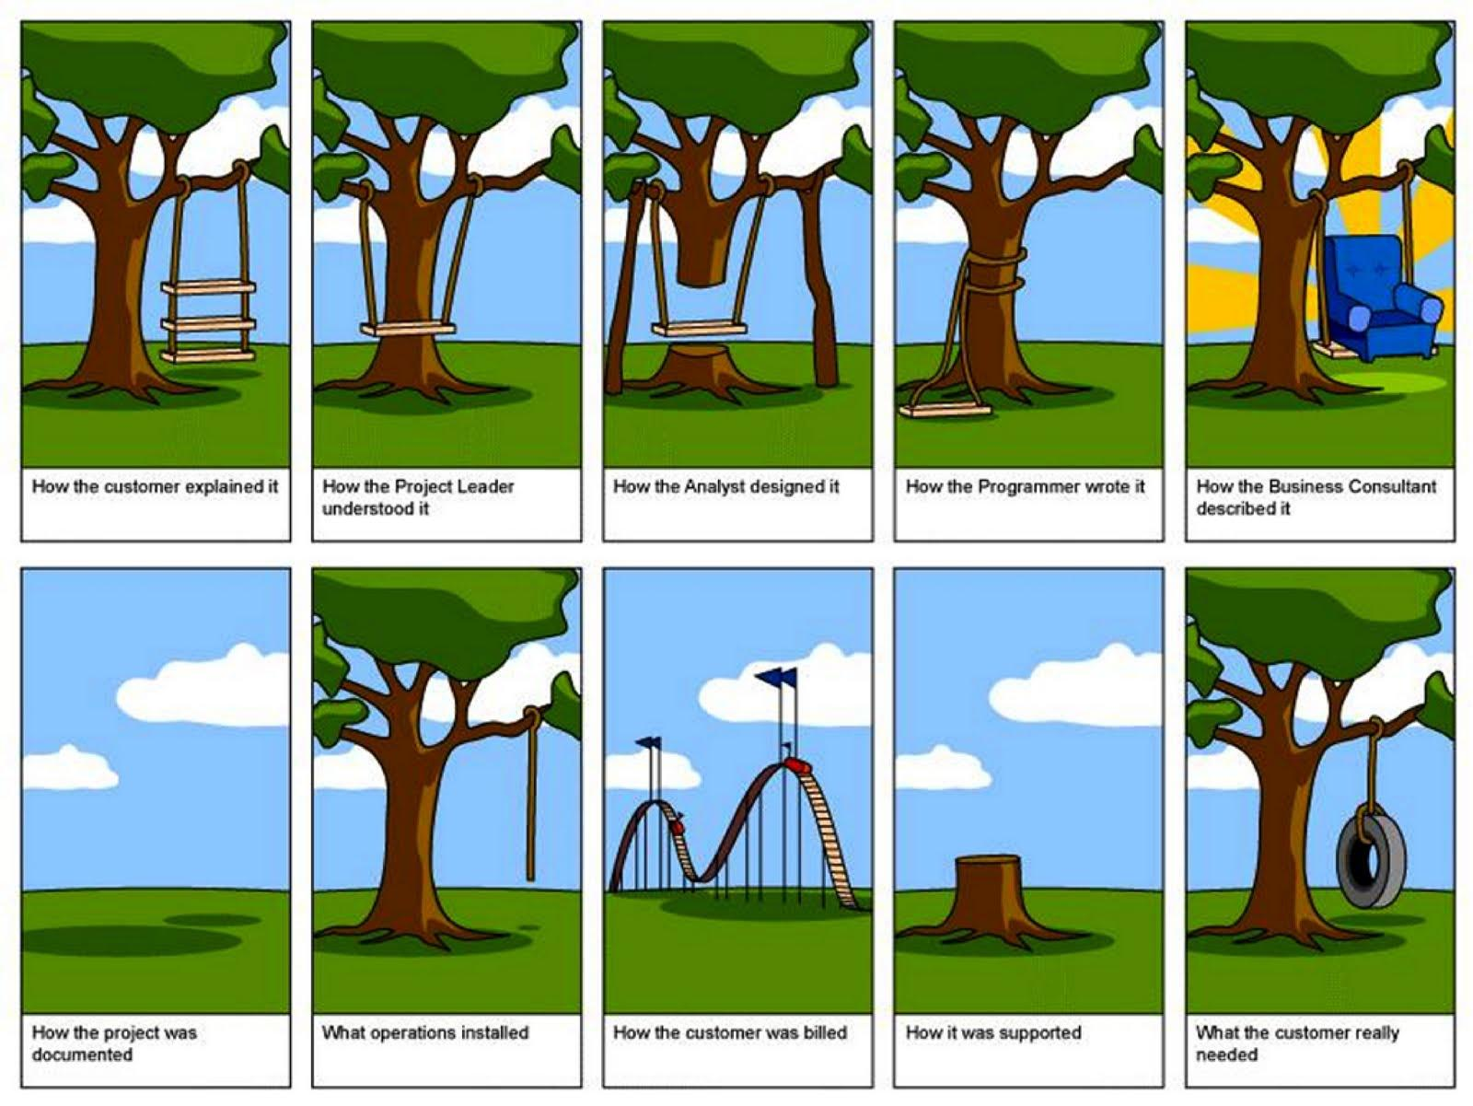

* Have you ever found yourself in the situation illustrated in the pictures?
* What are the negative effects of ineffective communication in the workplace?
* What do you normally do when you realize you fail to understand your teammate/your customer when discussing something in a meeting?

**2**. *We often ask for clarification when, for example, we don't know what someone has just said because we didn't hear them. Also, we might not know what someone meant because we didn't understand them. What do you say in such situations?*

* *Can you clarify that, please?*

***3 (a)*** *Watch four extracts. In which of them does the speaker:*

|  |  |
| --- | --- |
| [Extract 1](https://youtu.be/jJOYPHVVwKs?t=28m58s)  [Extract 2](https://youtu.be/T51xcOpz6Js?t=47m42s)  [Extract 3](https://youtu.be/epBisSuEix8?t=20m55s)  [Extract 4](https://youtu.be/8uQBHwqeB7E?t=2m12s) | 1. ask to repeat because he didn’t hear the question?  2. ask to explain because he heard the question but didn’t understand it?  3. give a long explanation and wants to check that people listening to him understood?  4. want to check that he understood? |

***(b)*** *Read the scripts and fill in the gaps with the missing words.*

#### A. [Extract 1](https://youtu.be/jJOYPHVVwKs?t=28m58s) [28:58 to 29:28]

#### Speaker 1: Daniel Lujan. I’m an old-time computer guy. Who do you think does a good job at the reputation for commerce? I mean, there are lots of people who’ve got them. Who’s doing a good job? Speaker 2: What do you mean ___ good job? Speaker 1: Well, you mentioned Ebay as seeming to have something that there’s enough people…

**B.** [Extract 2](https://youtu.be/T51xcOpz6Js?t=47m42s) [47:42 to 47:55]  
Speaker 1: Mm-hmm.  
Speaker 2: And you decrypt, does that decrypt everything into clear text?  
Speaker 1: **_____ that again. I didn't hear** **the last part.**  
Speaker 2: Sorry, so when you decrypt...  
Speaker 1: Uh-huh. man: The user's mailbox...

**C.** [Extract 3](https://youtu.be/epBisSuEix8?t=20m55s) [20:55 to 21:12]

Speaker 1: We have to fit all the balls into the shadow area.  
Speaker 2: Oh, OK. **So what you're** _____ ____ you've got two rows right now. If you were to stack it three-high, that's no good?  
Speaker 1: **Yes, _____** **correct.**

**D**. [Extract 4](https://youtu.be/8uQBHwqeB7E?t=2m12s) [2:12 to 3:06]  
Speaker 1: So most applications have an account creation process, sign-in process, maybe they have a walk-through or demo or something that they make you go through. What's your advice on that kind of thing? How do you handle account creation or demos or walk-throughs?

Speaker 2: That's a very good question. The most important thing right away when you actually first experience an application is for the application to give you an idea of what it's going to do. And if it needs you do something like sign in to tell you why. Then you'll be more eager to actually, for example, sign in. Now, once you've understood why you need to sign in and then you go to sign in, the application developer should take a lot of effort to remove any friction from that step as well. So that involves using something like sign in with Google, or log in with Facebook, or something like that. **Does that make** ________**?**

Speaker 1: Yeah.

*Now listen again and check.*

***4.*** *Sort the expressions highlighted in the transcripts into the table:*

|  |  |
| --- | --- |
| Asking to repeat because you didn’t hear |  |
| Asking for an explanation / clarification | * *Can you clarify that, please?* |
| Explaining / clarifying what you mean | * *What I mean is…* |
| Checking that **those who are listening to you** understood |  |
| Checking that **you** understood |  |
| Confirming that people listening to you understood you correctly |  |

***5a****. There are some other expressions that we can use to signal that you didn’t hear something, ask for an explanation or explain. Fill in the gaps in the phrases below:*

1. Sorry, I m__ __ __ __d that bit.
2. So b__ __ __ __ __ __ __y what I’m saying is…
3. Can you be a bit more s__ __ __ __ __ __ c __ __ __ __t [that]?
4. I’m not q__ __ __ __ sure what you mean by [access code]
5. Sorry, I didn’t c__ __ __ __ [the question].
6. If I understand you __ __ __ __ __ __tly, [what we need is a new system]

***b.*** *Now add these phrases to the table above.*

***6****. Read the scripts below and fill in the gaps with the expressions from the box.*

|  |
| --- |
| I missed that bit * didn’t catch * what I’m saying is * so you’re basically saying  can you be a bit more specific * if I understand you correctly |

[Extract 1](http://tubequizard.com/search.php?pattern=!Y2FuIHlvdSBiZSBhIGJpdCBtb3JlIHNwZWNpZmlj&quiz&video=ZQyrDoLqyJ0)   
Speaker 1: Paul, (1) ________________________ about what you mean by Wi-Fi communication channel. What are you trying to do?  
Speaker 2: I've kind of got this image of someone scanning an NFC card and then input in the…

[Extract 2](http://tubequizard.com/search.php?pattern=!d2hhdCBpJ20gc2F5aW5nIGlz&quiz&video=DujfpXOKUp8)

And, of course, remember that in some cases, it's not so bad to have -- to rely on synthesized DOM events like click, scroll, and context menu which all fire on touch devices. So, basically,

(2) _________________________ you don't need to implement touch-specific event handlers necessarily to have a good experience on touchscreens.

[Extract 3](http://tubequizard.com/search.php?pattern=!SWYgaSB1bmRlcnN0YW5kIHlvdSBjb3JyZWN0bHk&quiz&video=mhr4TWmMm98)

And perhaps what we need is a new foundation, maybe, to—(3) ____________________ -- to recreate the fundamentals of the financial service system. Maybe.

[Extract 4](http://tubequizard.com/search.php?pattern=!ZGlkbid0IGNhdGNo&quiz&video=TshYsRI4GUU)   
I, um, I (4) ________________ the question 'cause I was busy fixing the sound.

[Extract 5](http://www.tubequizard.com/search.php?pattern=!c28geW91J3JlIGJhc2ljYWxseSBzYXlpbmc&quiz&video=_CruQY55HOk)

PATRICK DUBROY: Yeah, I'm not sure if the GC looks at—(5) _____________________, I guess, that the collector is kicking in. It's not actually able to collect anything, so it …

[Extract 6](http://tubequizard.com/search.php?pattern=!SSBtaXNzZWQgdGhhdCBiaXQu&quiz&video=sZX9gaC_Uv8)

What was in relation to the Galaxy S3 you just mentioned? Sorry, (6) ____________________.

*Now listen to the extracts to check your answers.*

***7.*** *Nicolas is showing his coworker, Andreas, how to create a Drive application. Read their dialogue and fill in the gaps:*

N: I will implement and integrate a web-based text editor. Before coding, there are two things that you need to do. First, you need to register your application and then list your application.

A: (1)__________________________________________ (*check that you’ve understood*).

N: (2)_______________ (*confirm that Andreas understood correctly*). So, to register your application you have to go to the Google APIs console, create a new project and enable the Google Drive API and the Google Drive SDK. Then you need to create Oath2.0 credentials.

A: (3)________________________ (*say you didn’t hear*)  
N: (4)________________________________ (*repeat*). So, you would usually have to select web applications and provide the URL at which your app is hosted. You also need to configure the Google Drive specific features. (5)___________________________ (*explain what you mean*). You'll have to fill in some information about your application and provide some icons. Let me go through a few of these fields - they need special attention. For example, the open URL.

A: (6)_________________ (*ask for an explanation*)

N: The open URL is the URL to which we will be direct users when they open a file with your app. Also, you need to list the main file types and the extension that the app can open.

A: (7)________________________________(*check that you’ve understood*).

N: Exactly. For our app I’ll simply choose the basic text file MIME type and the TXT extension. It is usually best to list both MIME type and extensions. (8)______________ (*check that Andreas understands)*

***8****. Work with a partner. Student A, read a sentence. Student B, ask for clarification/ check understanding. Then swap roles. Use the language from the table in (4)*

A. Student A: The thing is, the customer wants to make a few changes to the project.

Student B: ______________________________ (check understanding)

B. Student B: The customer experienced a few problems while using the application – we'd like someone to deal with them.

Student A: ______________________________ (ask for clarification)

C. Student A: I suggest we come up with another solution – I'm afraid this one will not work.

Student B: ______________________________ (ask to repeat, then ask for clarification)

D. Student B: Some of our team members are using non-standard development processes.

Student A: _________________________________ (check understanding)

E Student A: I'm afraid your team needs to rewrite the code.

Student B: _______________________________ (check understanding)

F. Student B: We need someone to collect and analyze the requirements – this is urgent.

Student A: ________________________________ (ask for clarification)

G. Student A: It would be great if you could contact X and find out if they could help with the testing.

Student B: ________________________________ (ask for clarification)

H. Student B: I'm afraid we've fallen behind the schedule – any ideas how to solve this problem?

Student A: __________________________________(check understanding).

I. Student A: We'd like your team to finish the iteration by the end of the week at the latest.

Student B: __________________________________ (check understanding)

J. Student B: We've fixed all the bugs, but the system keeps crashing.

Student A: __________________________________ (ask for clarification).

***9.*** *Write a statement about each of the following:*

* a problem you’re trying to solve / a task you’re working on;
* a new device/technology/tool;
* your most challenging responsibility.

*Work with a partner and have mini-dialogues:*

Student A: Read your statement

Student B: Say that you don’t understand

Student A: Give an explanation

Student B: Report back what you’ve heard

in your own words

Student A: Reply

*Change roles.*